|  |  |
| --- | --- |
|  | **2019** |
|  | Idb-bisew  Mahabubur Rahman |

|  |
| --- |
| **[PHARMACY mANAGEMENT SYSTEM]** |
|  |

The Pharmacy Management System is a complete dispensing workflow management system that is designed to improve accuracy, enhance safety and efficiency. But theCareAlways pharmacy unit still use the manual system. And this manual system requires the pharmacist to manually monitor each drug that is available in the pharmacy.

This involves manual entry upon arrival of new batches of drugs and dispensing of drugs to patients etc. Upon a certain period (Ex: every month) the pharmacist is required to generate reports manually, on the movement of drugs. This is to monitor and refill the already diminishing stocks. However, this can usually lead to so many errors and the workload of pharmacist will increase. As a result, sometimes, patient care, in terms of counselling, is compromised due to time constraints. Therefore, the most urgent concern of Care Always pharmacy is to develop a automated Pharmacy Management System which help them to improve inventory management, cost savings, medication safety that can be managed efficiently in one package.

**Main two requirements of the system:**

1. The system must include managing of Stock (Inventory), Purchase of drugs and Sales of drugs.
2. Reports for the above three processing steps, Such as;

* Stock Management= Stock, location or expiry reports etc.
* Purchase of Drugs= Purchase summary or Invoice reports etc.
* Sales of Drugs= Price changed items or cash sales reports etc.

**User Characteristics of Pharmacy Management System:**

‘The System’ has basically five types of user.

1. Super Admin
2. Admin
3. Pharmacist
4. Cashier
5. User/Customer
6. Super Admin is the one who controls the complete system. He can manage all the functionalities of the system. Administrator validates user information and creates them and he looks over the stock in the database.
7. Admin is one of the user who can view and manage the stocks in the database and can view all the users of application. He can even view the prescription generated by the cashier.
8. Pharmacist is also a user of the application who adds the stock to the database and manage the stokes in the database.
9. Cashier is also a user this application who takes the invoice no and generates the bill or invoice of the medicine and takes the money from the customer by diff means like cash, credit card etc.
10. User/Customer is also user of the application who registration and add to card and view own profile.

**Analysis and Design Part:**

1. Brainstorming Diagram:

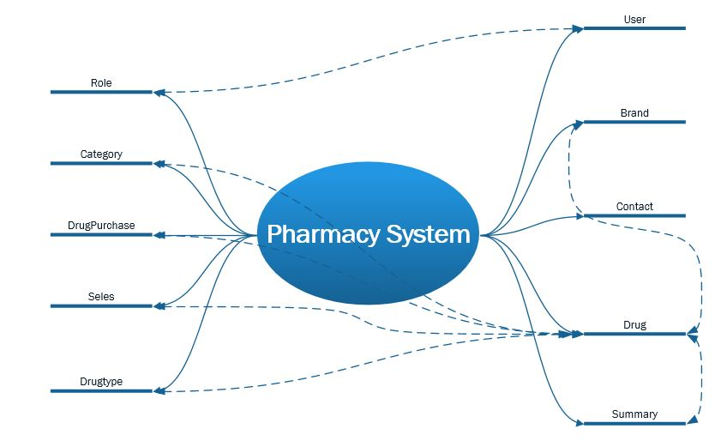

1. Use Case Diagram:

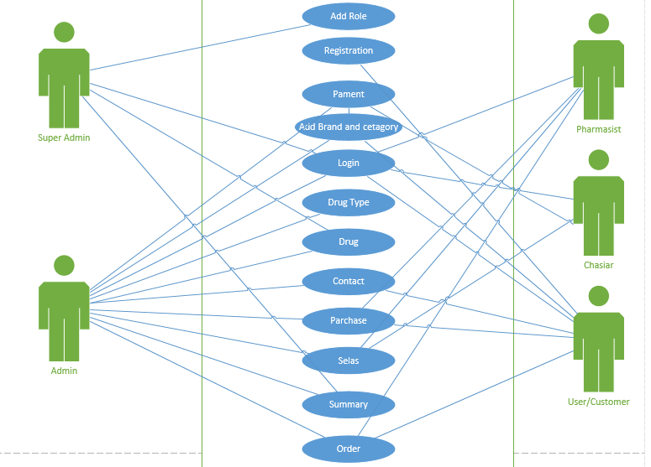

1. Class Diagram:

